

SIMATS ENGINEERING

Saveetha Institute of Medical and Technical Sciences
Chennai- 602105

Student Name: P. Aufrin Reg. No.: 192473029
Course Code: DSA0615 Slot: A
Course Name: Data Handling & Visualization for Data Analytics
Course Faculty: Dr. Kumaragurubaran T & Dr. Senthilvadivu
Project title: Eco sense - Smart air quality monitoring dashboard
Module Photographs: (3 photographs –Module Photo, Individual student contribution module work in the project and presentation image)
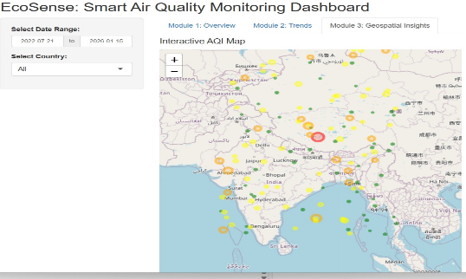
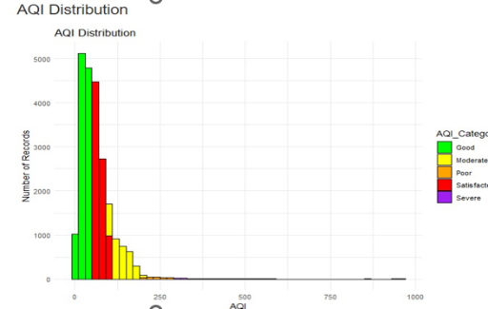
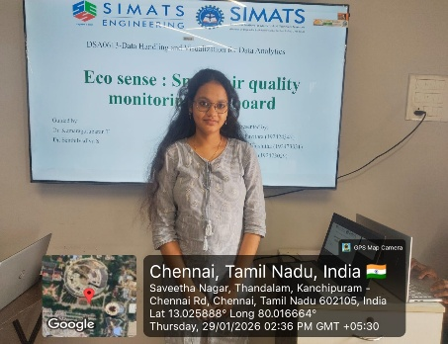

Project Description: (here you write what you did in this project contribution) including Model Description.
Geospatial and Smart Insights refers to the analysis and interpretation of location-based data to uncover meaningful patterns, trends, and relationships. By combining geospatial techniques with smart analytics, it helps in visualizing data on maps, identifying hotspots, and supporting data-driven decision making. These insights enable better planning, monitoring, and management in areas such as urban development, environmental monitoring, transportation, and smart city applications. Geospatial and Smart Insights combine location-based data with smart technologies to provide actionable intelligence. By analyzing spatial information through maps and dashboards, it supports efficient resource management, environmental monitoring, traffic analysis, and smart city planning.

Student Signature Guide Signature

